# Relational Databases with MySQL Week 4 Coding Assignment

**Points possible:** 70

|  |  |  |
| --- | --- | --- |
| Category | Criteria | % of Grade |
| Functionality | Does the code work? | 25 |
| Organization | Is the code clean and organized? Proper use of white space, syntax, and consistency are utilized. Names and comments are concise and clear. | 25 |
| Creativity | Student solved the problems presented in the assignment using creativity and out of the box thinking. | 25 |
| Completeness | All requirements of the assignment are complete. | 25 |

**Instructions:** Using a text editor of your choice, write the queries that accomplishes the objectives listed below. Take screenshots of the queries and results and paste them in this document where instructed below. Create a new repository on GitHub for this week’s assignments and push this document, with your Java project code, to the repository. Add the URL for this week’s repository to this document where instructed and submit this document to your instructor when complete.

**Coding Steps:**

Write 5 stored procedures for the employees database.

Write a description of what each stored procedure does and how to use it.

Procedures should use constructs you learned about from your research assignment and be more than just queries.

**Screenshots:**

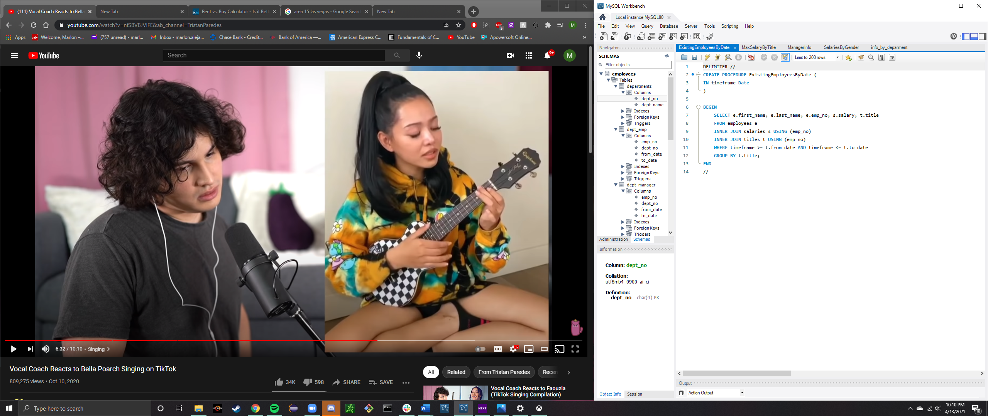

This procedure allows us to to search for active employees that were working during a specific date that we input when we call for the function.

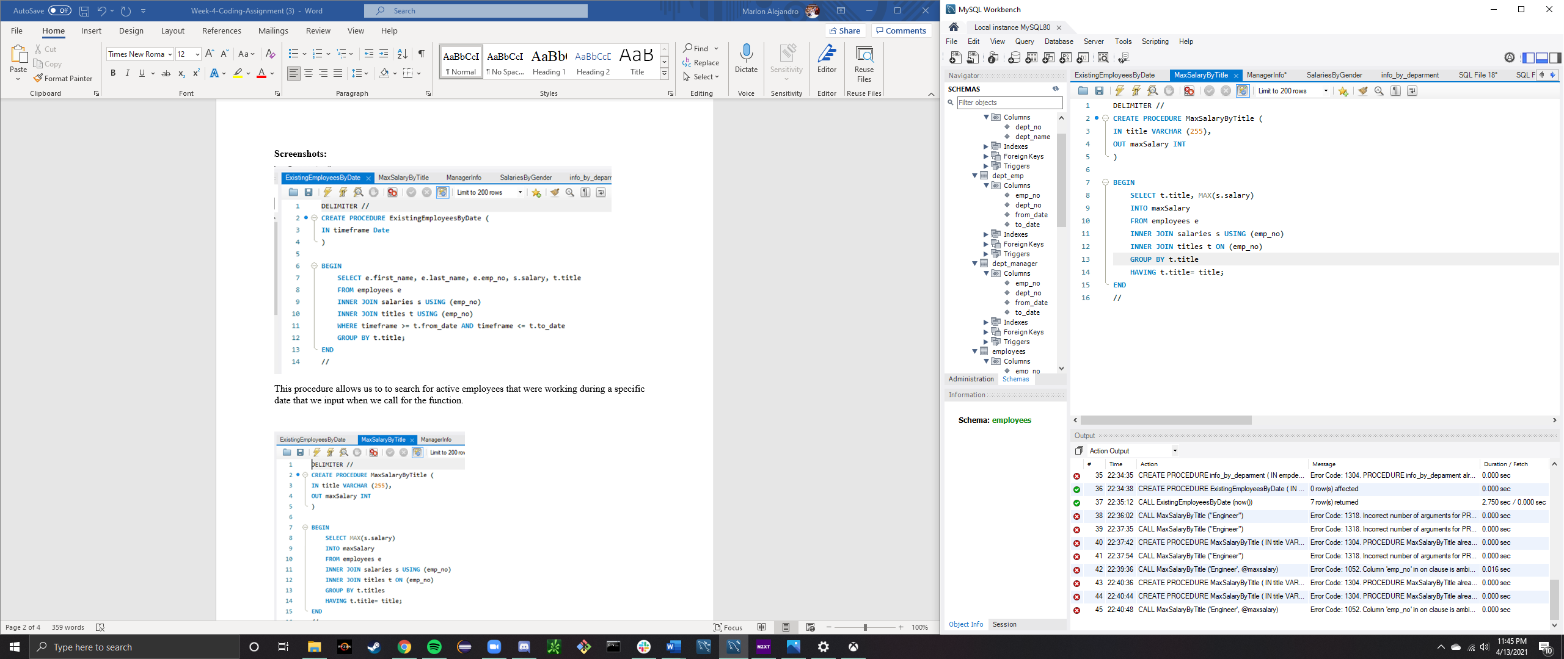

This function allows us to find the maximum salary of a specific title. When we call for the function, we input a title we are looking for it should output the maximum value that position’s salary.

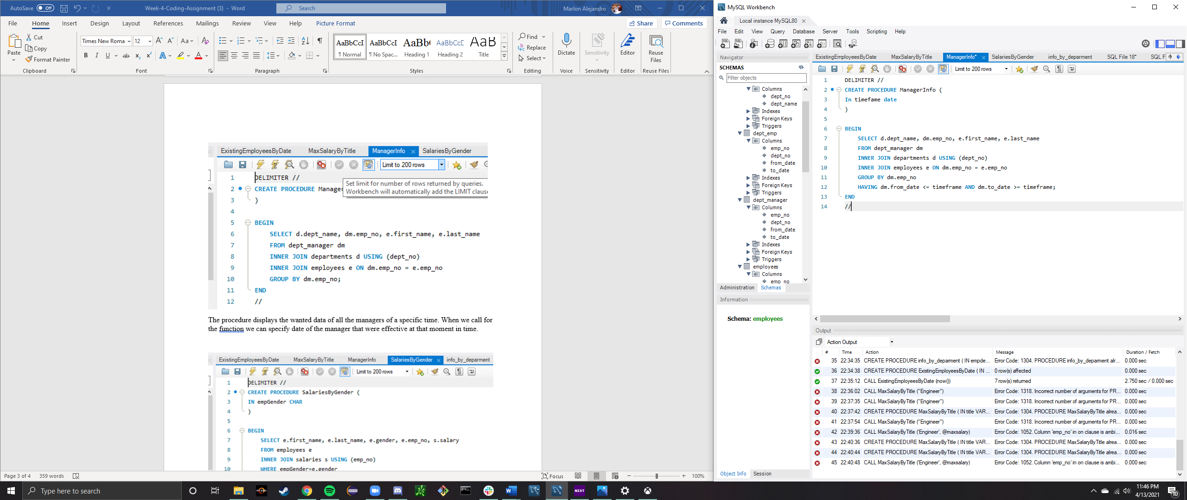

The procedure displays the wanted data of all the managers of a specific time. When we call for the function we can specify date of the manager that were effective at that moment in time.

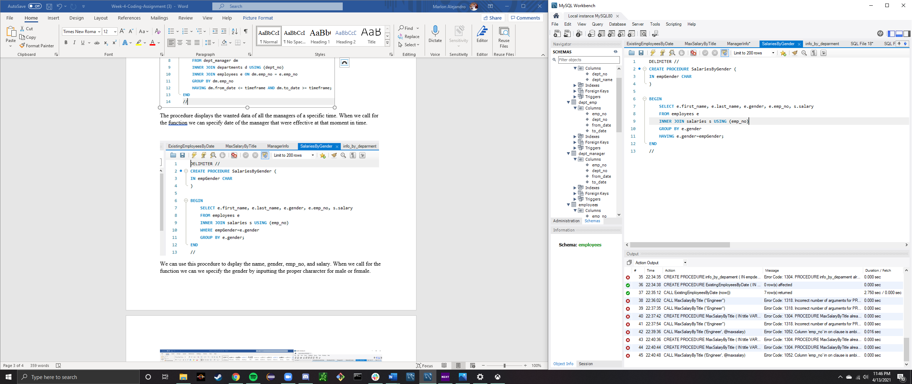

We can use this procedure to dsplay the name, gender, emp_no, and salary. When we call for the function we can we specify the gender by inputting the proper chararcter for male or female.

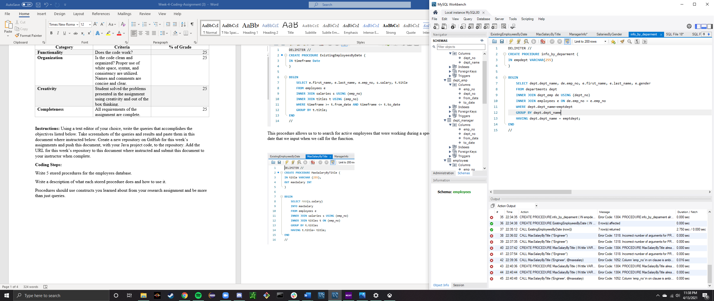

This function displays the information for the employees for a specific department. When we call for the function, we can have it search for the department by the input in our query.

**URL to GitHub Repository:**